1. Before explaining the structural directive, let’s see why this \* start before \*ngFor is required.
2. This start indicates to angular that this is structural directive.
3. This is transformed into something else as there is no star in angular syntax when using directive or property binding.
4. There are only
   1. Property Binding.
   2. Event Binding,
   3. Two-way Binding,
   4. String Interpolation
5. So, in the end, angular needs to transform \* into something one of the above and it does.
6. 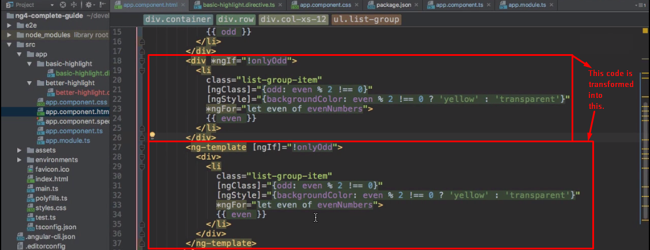  
    NOTE: <ng-template> is not rendered itself but contains template which would be rendered based on some condition’s true value.